

A Project Report On

“Mentor Mentee Diary” Submitted To

The Department Of Computer Studies

CSIBER, Kolhapur

(An Autonomous Institute)

For The Partial Fulfilment Of

MASTER OF COMPUTER APPLICATION

SEM-II

By

Miss. Chougale Nisha Pandurang(Exam No.:5510)

Under The Guidance Of

Dr . Mr . Ajay D. Shinde **(**M.C.A., Ph. D. (C.S.))

# CHHATRAPATI SHAHU INSTITUTE OF BUSINESS

EDUCATION AND RESEARCH(CSIBER), KOLHAPUR.



**CHHATRAPATI SHAHU INSTITUTE OF**

**BUSINESS EDUCATION AND RESEARCH, KOLHAPUR.**

# CERTIFICATE

**DEPARTMENT OF COMPUTER STUDIES**

This is to certify that Miss. Chougale Nisha Pandurang (Exam

No. : 5510) has satisfactorily completed the Mini Project work on

“Mentor Mentee Diary” developed through “PHP, Javascript, MySQL” for the partial fulfilment of MCA-I(Sem-II) submitted to Chh. Shahu Institute Of Business Education And Research, Kolhapur during the academic year 2020-21.

To be the best of my knowledge of programs ad outputs submitted by them are developed on their own their own and not copied from any source.

Place : Kolhapur Date :

H. O. D. Examiner

(MCA Dept, CSIBER )

# DECLARATION

To,

The Director,

CSIEBER, Kolhapur.

Respected Sir,

I undersigned Miss. Chougale Nisha Pandurang (Exam No.: 5510) hereby declare that, the project report “Mentor Mentee Diary” submitted by me, under the guidance of Dr . Mr . Ajay D. Shinde, is my original work. The project presented is developed by me independently and is not duplicate from any other source.

The work here by submitted to Chh. Shahu Institute Of Business Education And Research , Kolhapur for partially fulfilment of MCA-I(Sem-II) Mini project.

I understand that any such copying is liable to punish in a way that University Authorities dream fit.

Place : Kolhapur Date :

Miss. Chougale Nisha Pandurang . (Exam No. : 5510)

# Acknowledgement

I sincerely express my deep felt gratitude to number of people who have helped us throughout my project work.

I wish to express by indebtedness and thankfulness to our H . O .D . Prof. Dr . Mrs . P. G. Naik, for their encouragement without which we could not complete my project task.

I would also like to convey my feeling of gratitude to our mentor Prof. Dr . Ajay D. Shinde who has guided me throughout project work with his immense knowledge and has encouraged me throughout.

Also I would like to take an opportunity to thank all our MCA department faculty for extending their full support.

Lastly, I would also thank my parents and friends who have helped us directly or indirectly.

Place : Kolhapur Date :

Miss. Chougale Nisha Pandurang(Exam No. : 5510)

# INDEX

|  |  |  |
| --- | --- | --- |
| **Sr. No.** | **Particulars** | **Page No.** |
| **1.** | **Introduction To Project**   * **Introduction** * **Language Used** | **01-04**  **02-03**  **03-04** |
| **2.** | **System Requirements**   1. **Need and Motivation** 2. **Objectives** 3. **Requirements**     1. **Hardware Requirements**    2. **Software Requirements** | **05-07**  **06**  **06**  **06**  **06-07**  **07** |
| **3.** | **System Analysis**   1. **DFD** 2. **ERD** | **08-16**  **09-13**  **14-16** |
| **4.** | **System Design**  **1. Database Design** | **17-21**  **18-21** |
| **5.** | **Output Screen** | **22-34** |
| **6.** | **Report** | **23-44** |
| **7.** | **User Manual And Findings**   * **Conclusion** * **Limitations** * **Future Enhancement** * **Bibliography / References** | **45-52**  **45-46**  **47-48**  **49-50**  **51-52** |

# INTRODUCTION

**TO**

**PROJECT**

**Introduction**

* Mentor is the main person we rely on to give us advice and guidance, especially in are career.
* Mentor is student – centric teacher or friend.
* Mentee is a person being mentored by mentor.
* The partnership between mentor and mentee is known as mentoring.
* Mentors act as a support system for mentees.
* Mentee act as a planner and investigator.
* In mentor mentee diary all those academic activities such as project, seminar , term paper etc. are carried out and timely recorded in detail.
* Such programs are completed by mentees under the guidance of respective mentors.
* In this system , we are going to provide the details as mentioned above.
* The system mainly includes three modules that are Admin, Mentor, and Mentee.
* Admin registers the mentors and mentees. Then mentors are assigned to respective mentees by guide.
* Then mentors and mentees communicate with each other for mentee’s academic activities like project, term paper, seminar etc.
* At the time of discussion for any academic activity, mentor accepts or suggests any modification with respect to subject.
* Also at every stage, mentors assign tasks to their mentees and assess their progress and if required, mentors suggest required changes to mentees. After verse mentees complete and submit their tasks with proper modification to mentors.
* In this way, mentees complete their academic activities under the guidance of mentors.

**Language Used**

##  HTML :-

* HTML stands for Hyper Text Markup Language.
* It is standard markup language for creating webpages.
* HTML consists of various elements also it describes the structure of webpage.
* HTML elements tells the browser how to display the contains.

##  CSS :-

* CSS stands for cascading style sheets.
* CSS describes how HTML elements are to be displayed on screen.
* It can control the layout of multiple webpages all at once.

##  Javascript :-

* Javascript is client side scripting language.
* Javascript is useful for creating dynamic web pages.
* Javascript is case sensitive programming language.

##  PHP :-

* PHP is an acronym for “PHP: Hypertext Preprocessor”.
* PHP is open source and widely used server side scripting language.
* PHP file can contain text , html , css , javascript and php code.
* PHP runs on various platform(windows,unix) and files have extension .php

###  MYSQL :-

* MySQL Server is one of the most popular open source database.
* SQL is an abbreviation for Structure Query Language.
* MySQL is used with other programs to implement applications that need relational database capability.

## **SRS**

**(SOFTWARE**

**REQUIREMENTS**

**SPECIFICATIONS)**

**System Requirements**

### a) Need And Motivation:-

* As all we have suffered from pandemic situation because of Covid-19. Almost whole world was about to stopped .
* But field of Information Technology(IT) found out the best solution over pandemic situation to resume world’s activities again.
* During this period, everything became online. The world didn’t stop working because of trending technology that is helping us to carry out our activities.
* In the same way, education is also going on in online mode.
* With Covid-19 protocols, educational activities are going on. In accordance with this, the system is implemented.

### b)Objectives:-

o All educational activities should be performed timely.o To maintain schedule of all activities. o The system follows Covid-19 protocols.

### c)Requirements:-

**i) Hardware Requirements-**

1. Processor : x64.
2. 4 GB (64 bit) RAM.
3. Hard Disk : Up to 200 MB of available space required.

**ii) Software Requirements-**

* 1. **Front End:** 
     1. HTML
     2. CSS
     3. PHP
     4. NetBeans IDE 8.0.2
     5. **Operating System:** o Windows 10
     6. Microsoft Office Word.
  2. **Back End:** 
     + 1. MySQL
       2. XAMPP
  3. **Browser:**

Google Chrome, Internet Explorer

**SYSTEM**

**ANALYSIS**

**DFD(Data Flow Diagram):**

* Data Flow Diagram(DFD) describes the flow of data or information into and out of the system.

* “DFD is **the graphical representation of the flow of data from one component to another component in any information system.**”

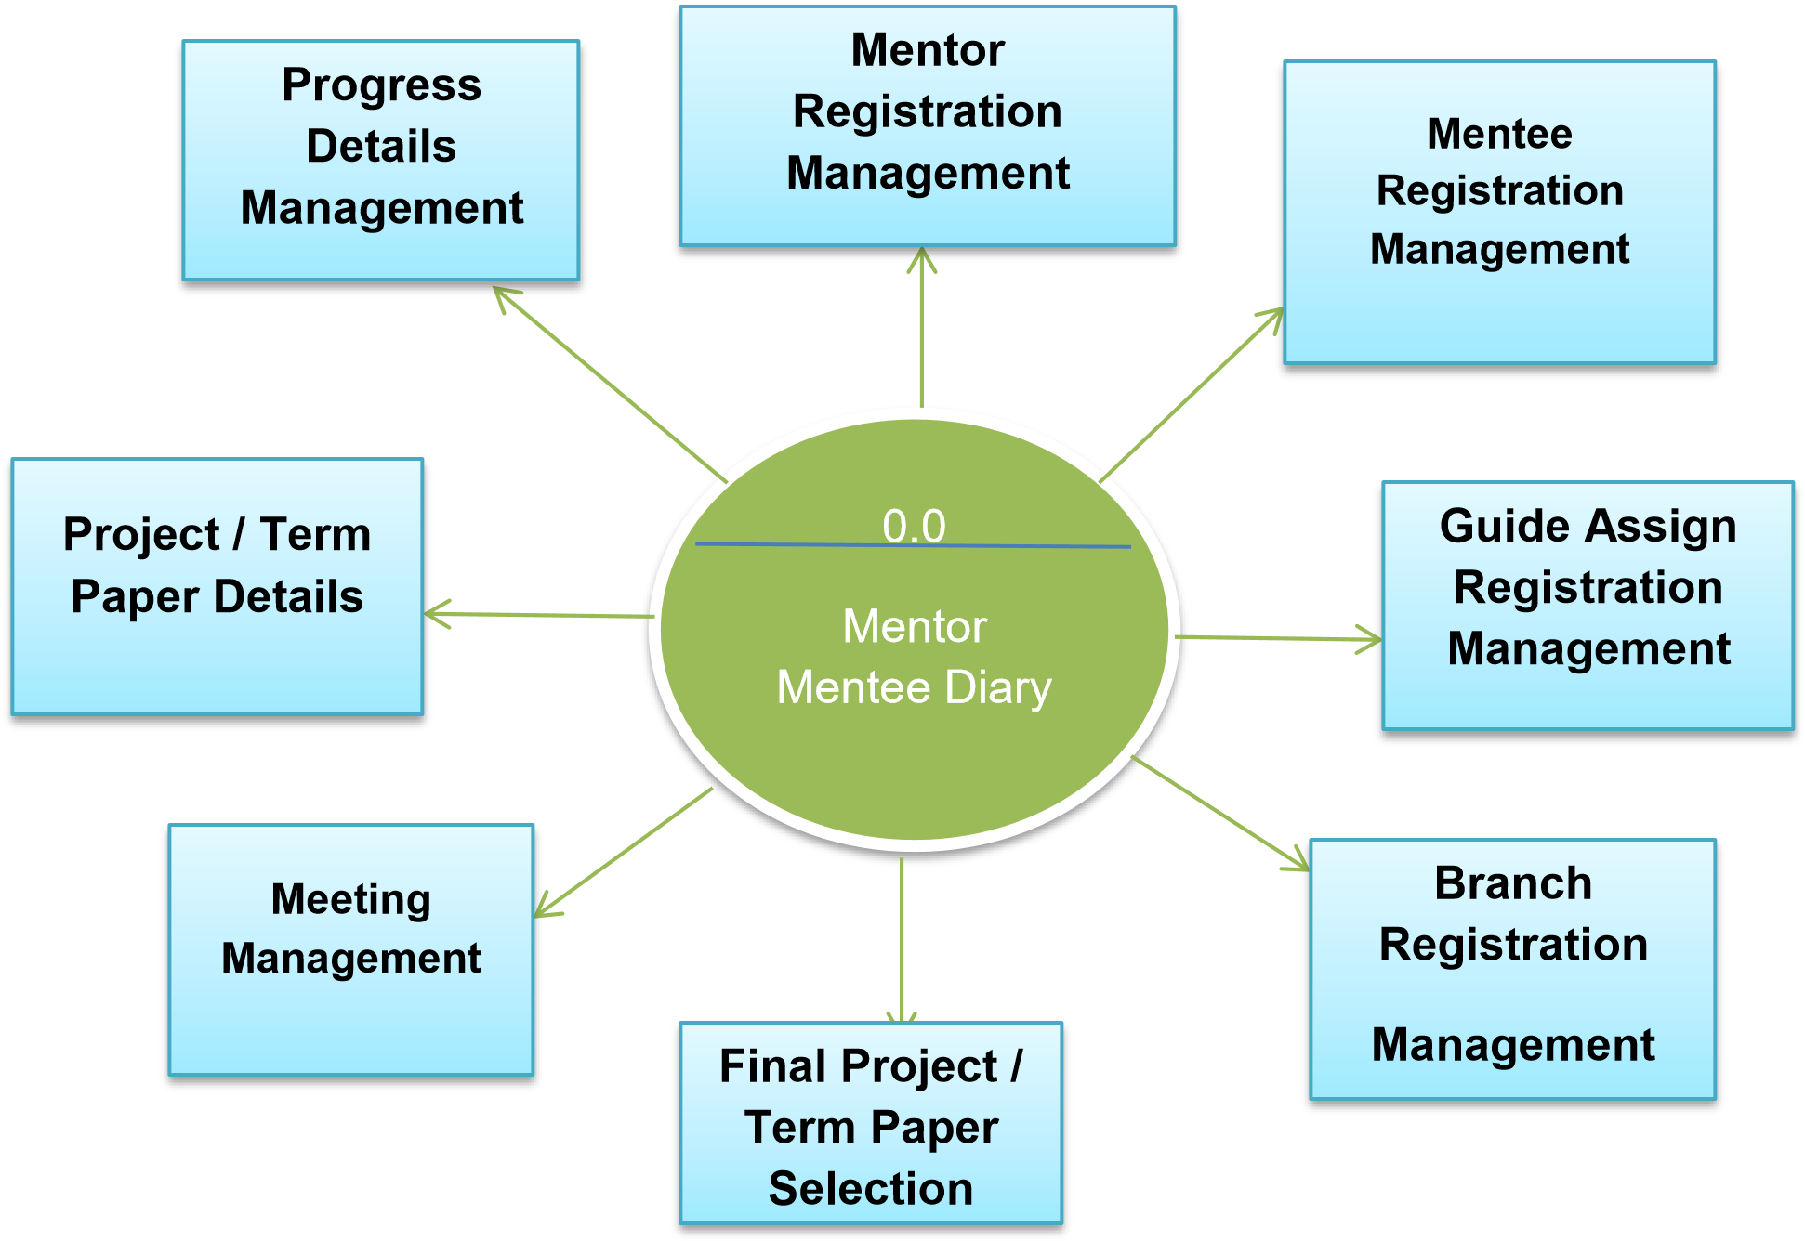

**Fig.: Zero Level DFD**

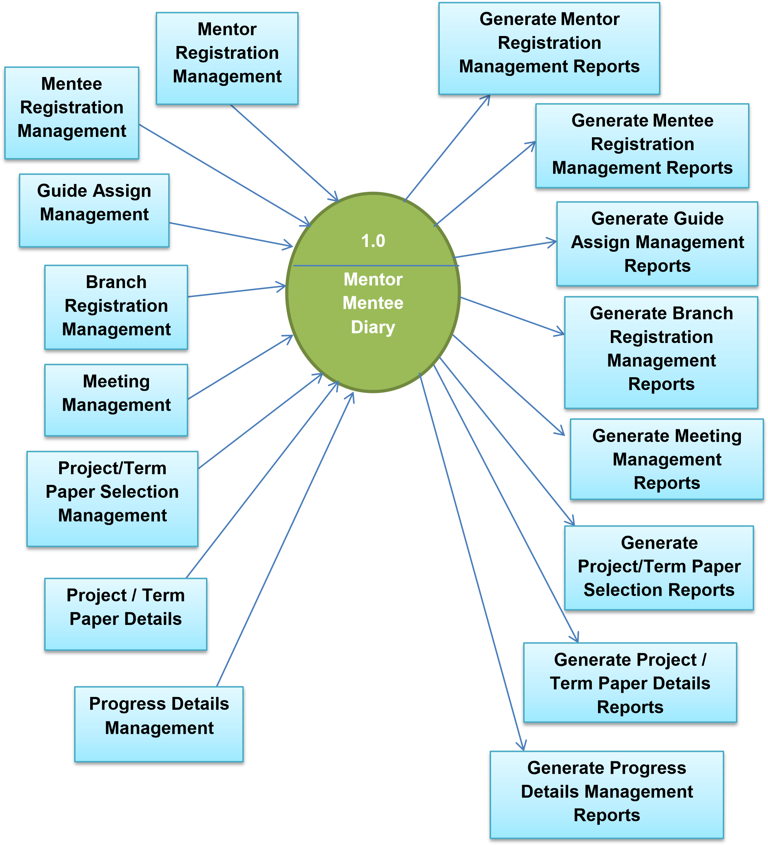

**Fig.: First Level DFD**

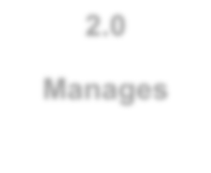

**2.0**

**Manages**



**Admin**



**Mentor DB**



**Mentee DB**



**Guide**

**DB**



**Branch DB**

**Fig.: Second Level DFD**

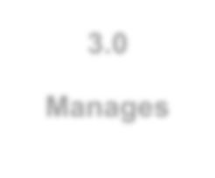

**3**

**.0**

**Manages**



**Mentor**



**Meeting**

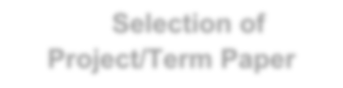

**Selection of**

**Project/Term Paper**



**Progress Details**

**of Mentee**

**Fig.: Third Level DFD**

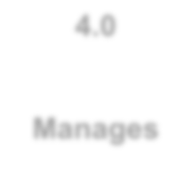

**4**

**.0**

**Manages**



**Mentee**

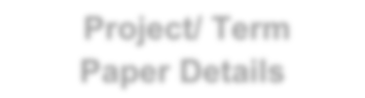

**Project/ Term**

**Paper Details**



**Progress**

**Details**



**Attends Meeting**

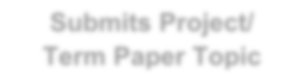

**Submits Project/**

**Term Paper Topic**

**Fig.: Fourth Level DFD**

**ERD(Entity Relationship Diagram):**

* “An Entity Relationship Diagram(ERD) is **graphical representation of an information system that shows the relationship between people, objects, places, concepts or events within that system.**”

* There are three components of ERD as- 
  + Entity
  + Attributes
  + Relationship etc.

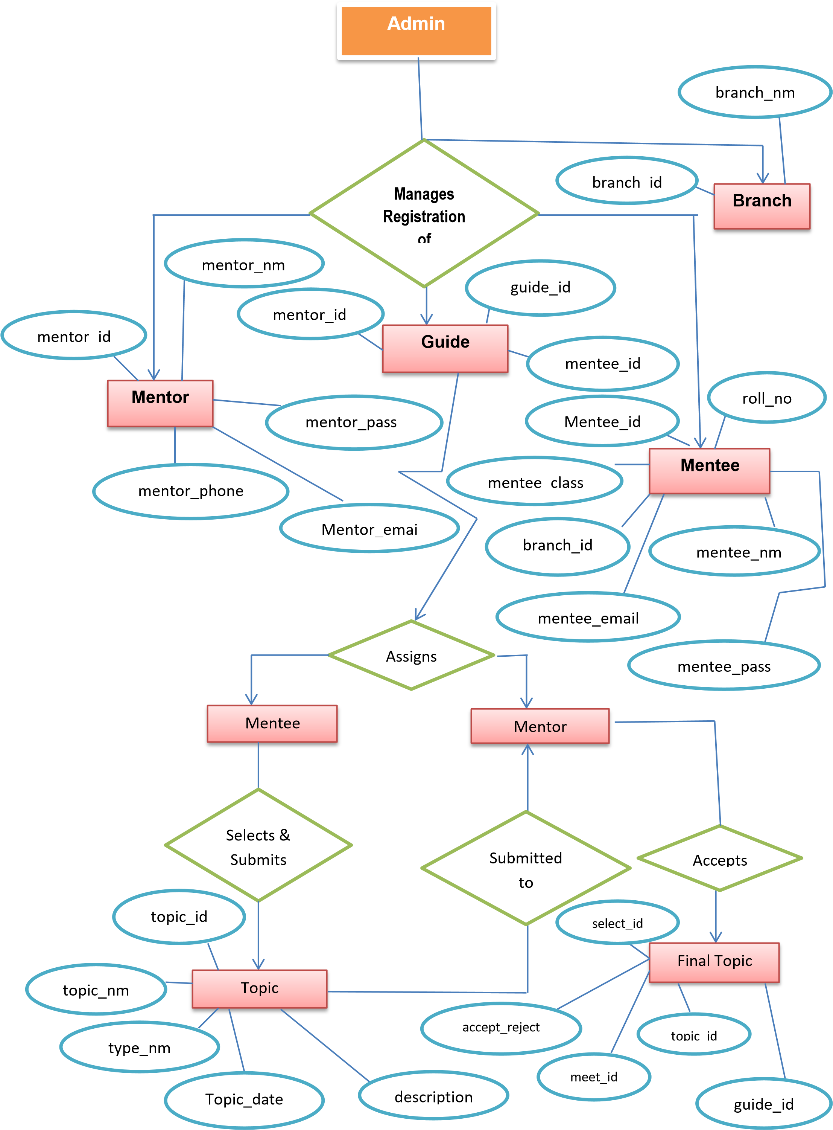

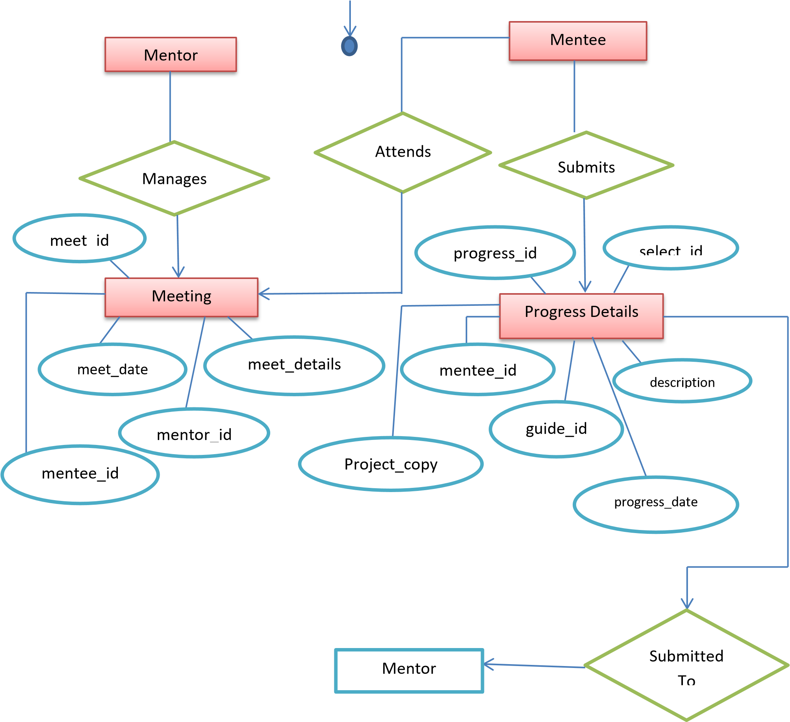

**System**

**Design**

**Database Design**

**1)**

**Mentor**

**2)**

**Mentee**

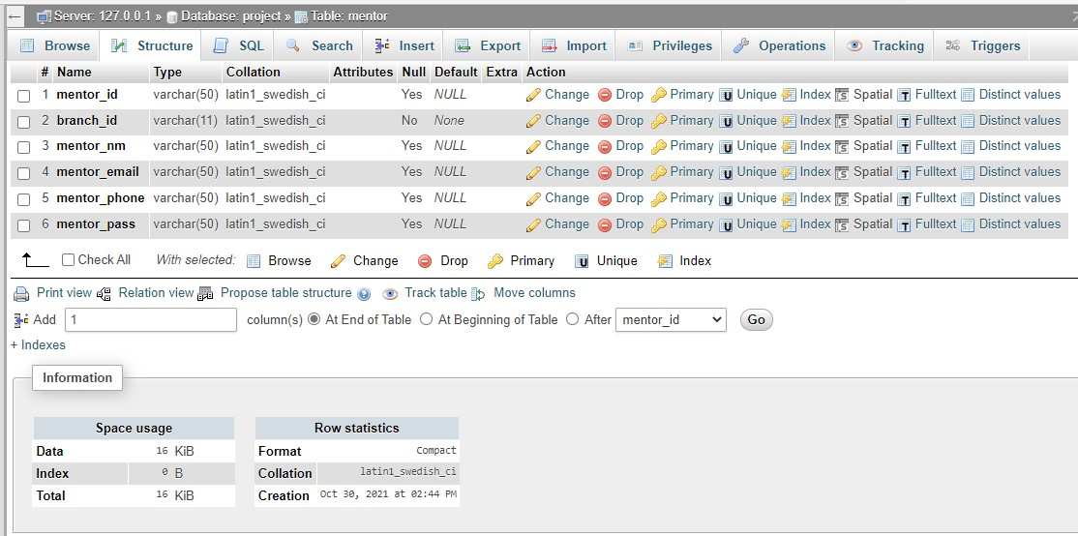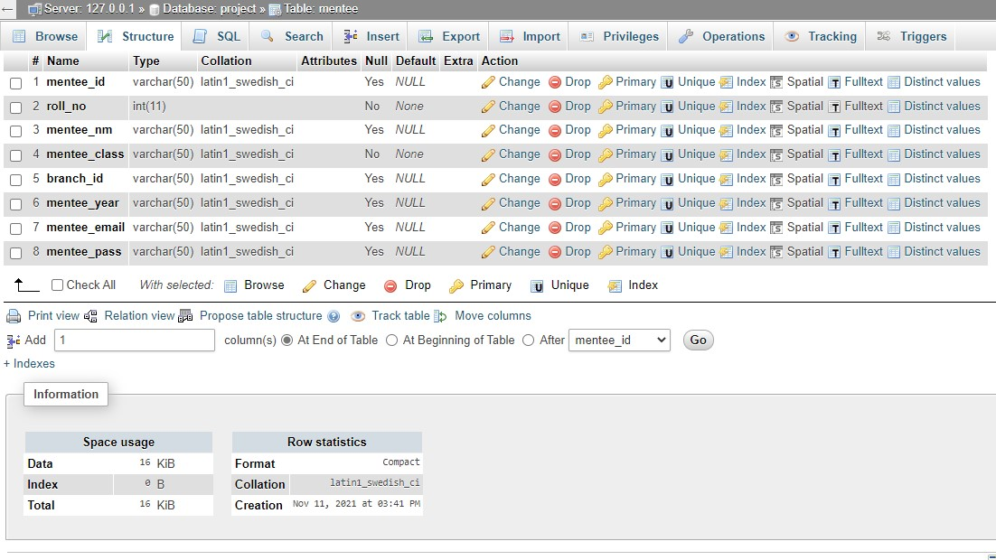

1. **Guide Assign**

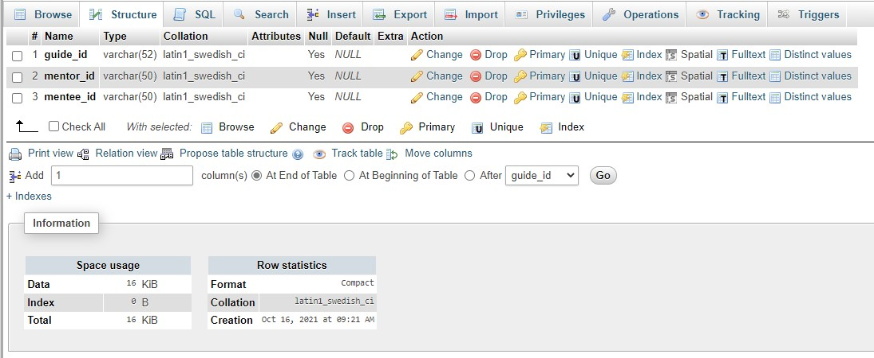

1. **Branch**

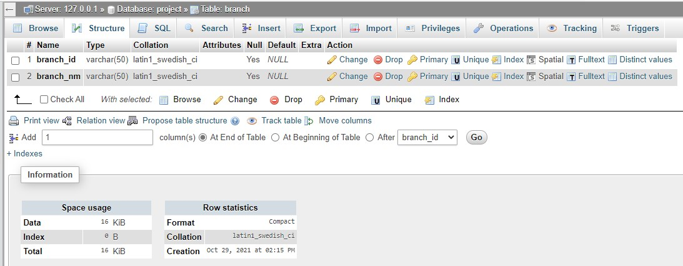

1. **Final Project / Term Paper Selection**

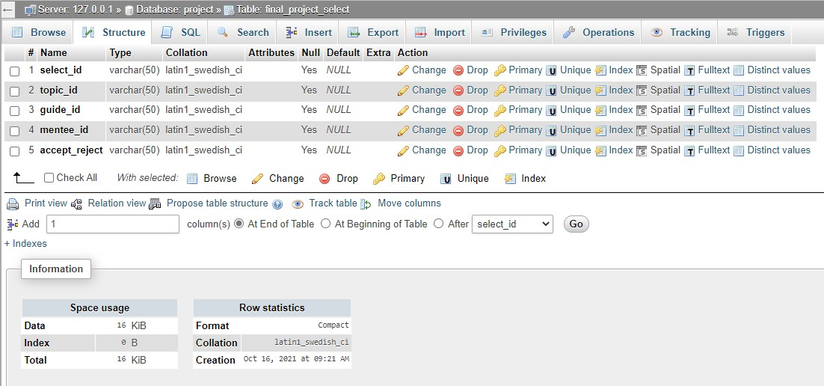

1. **Meeting**

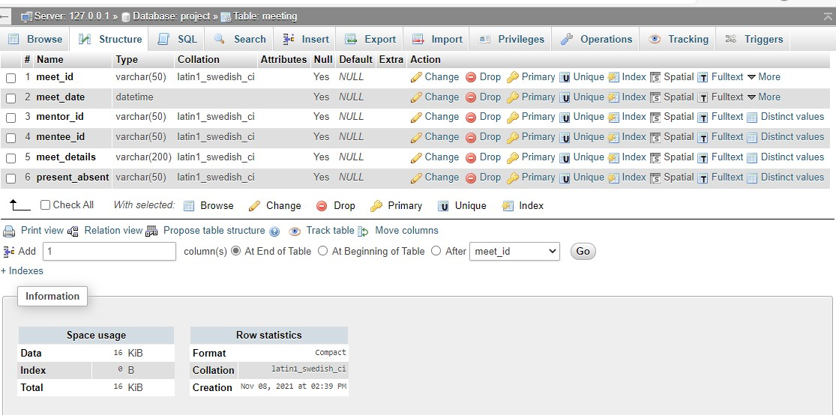

1. **Project / Term Paper Topic Details**

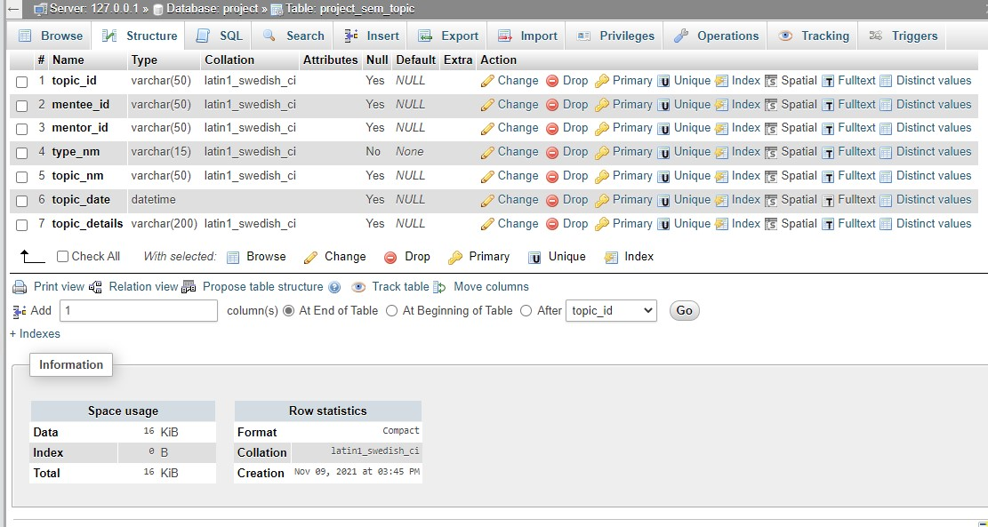

1. **Progress Details**

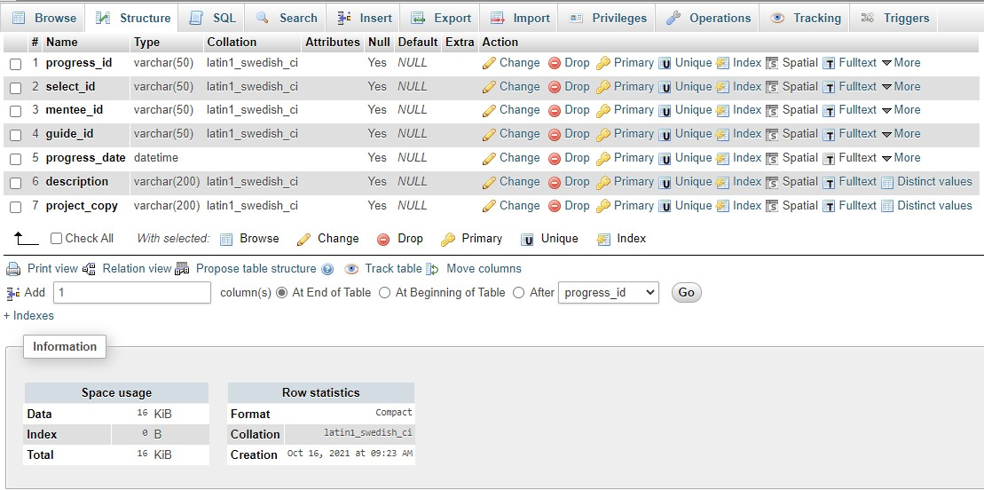

**OUTPUT**

**SCREEN**

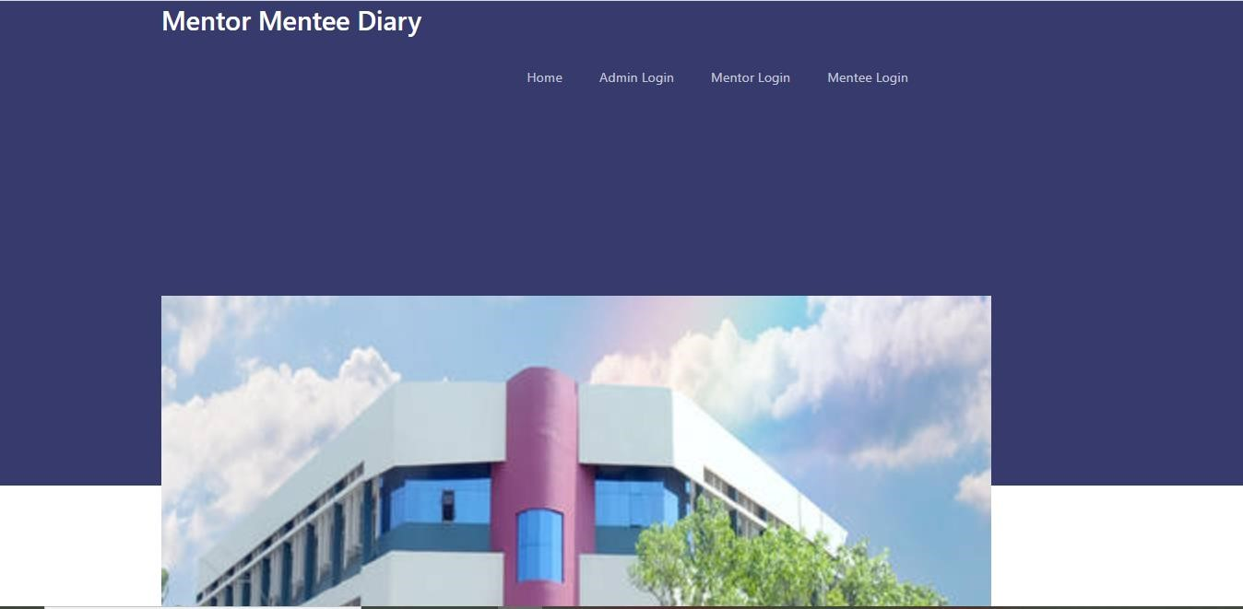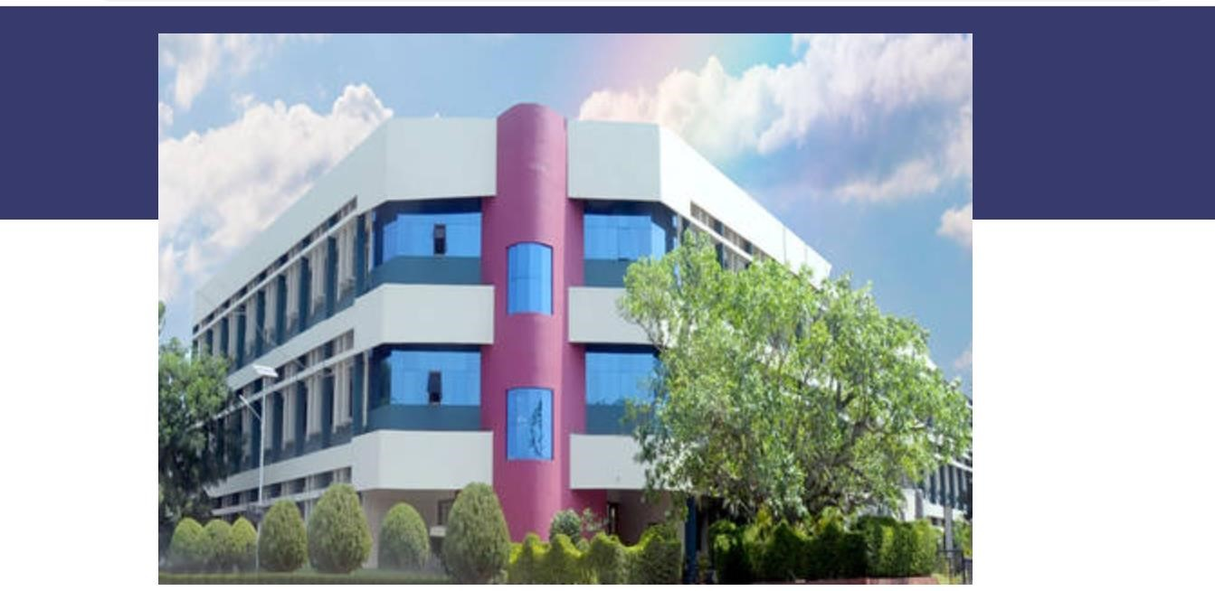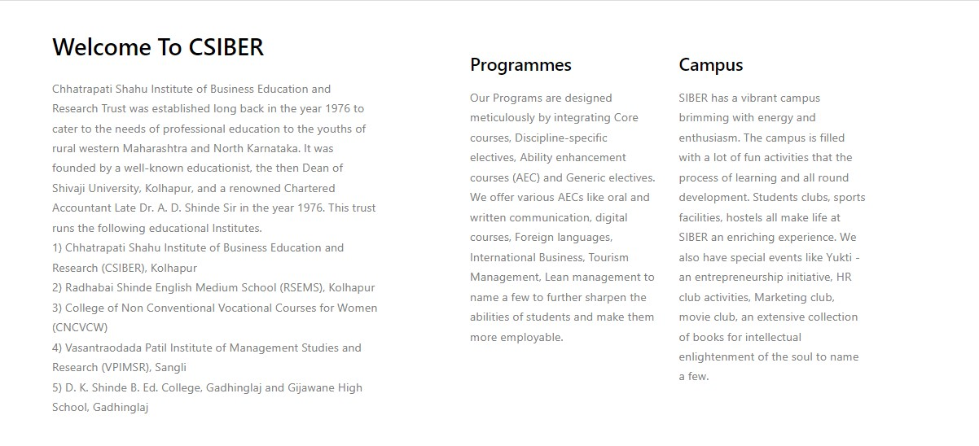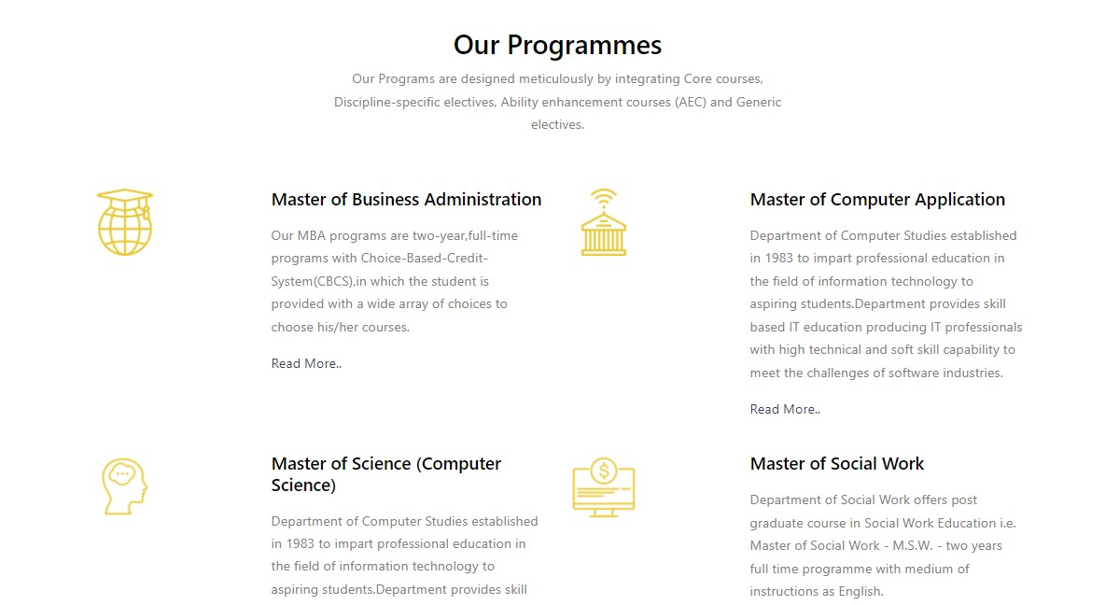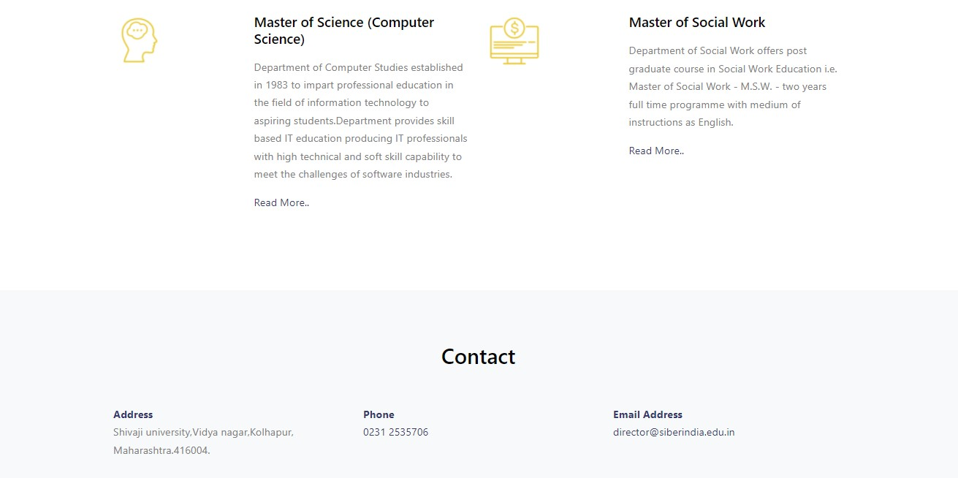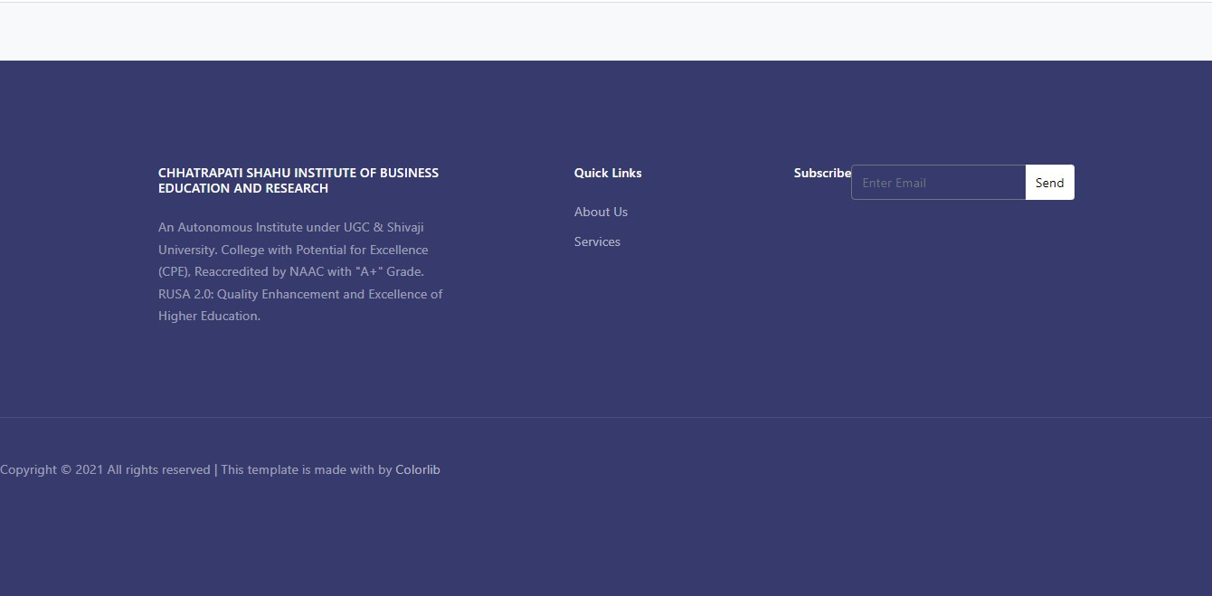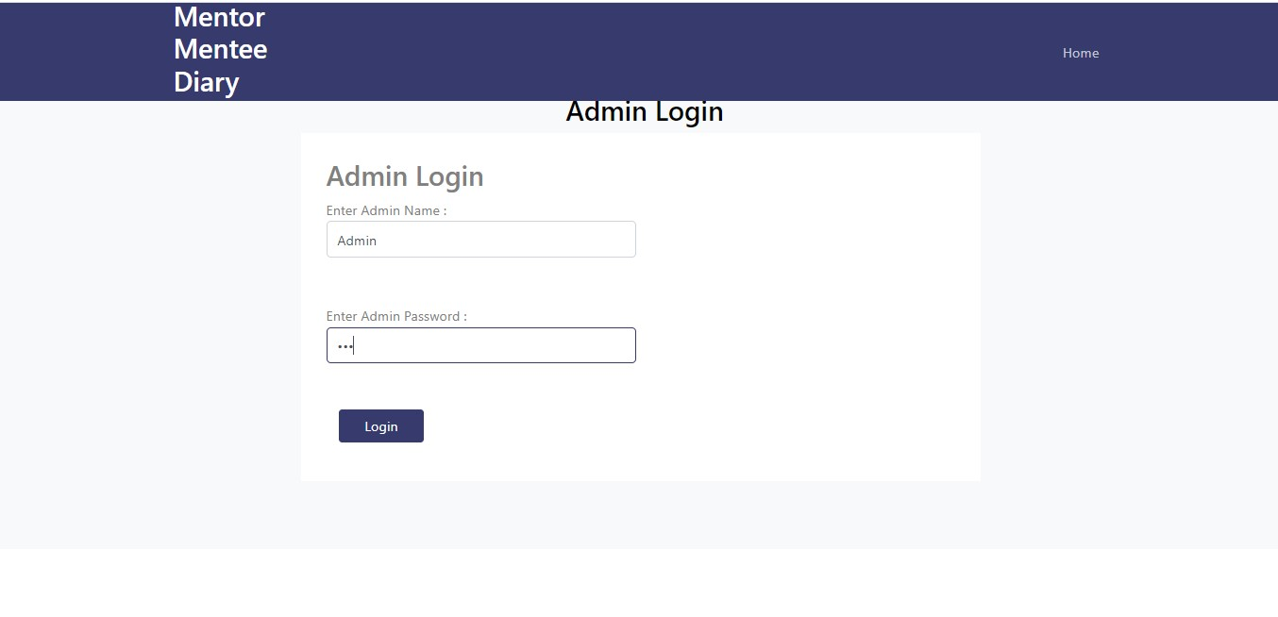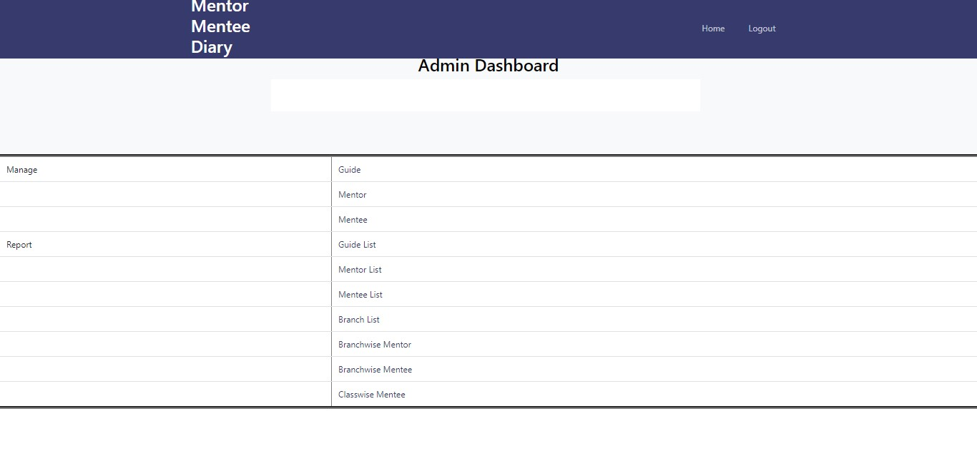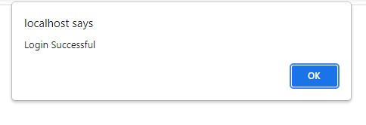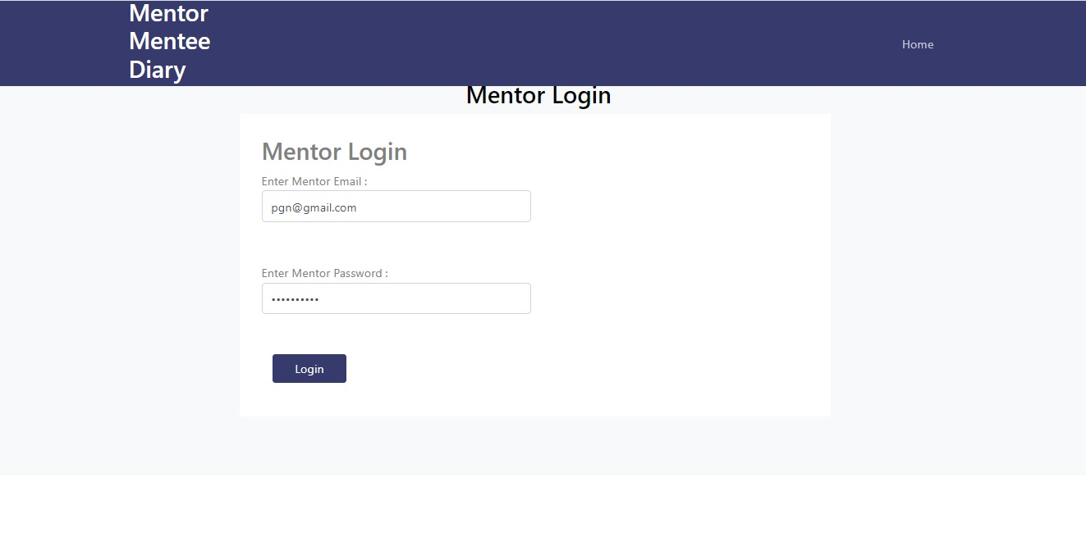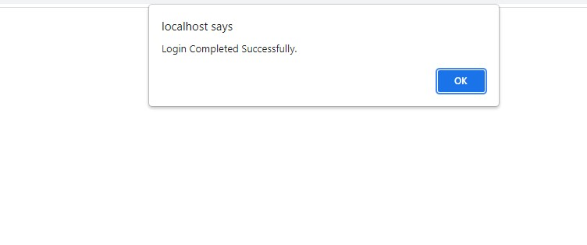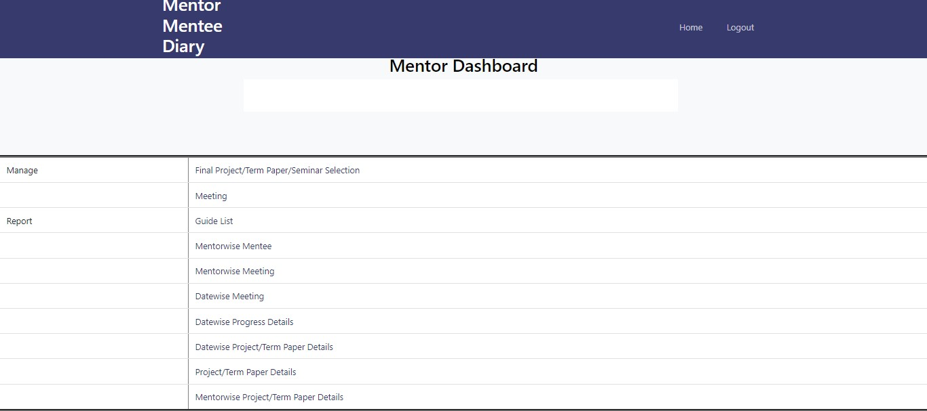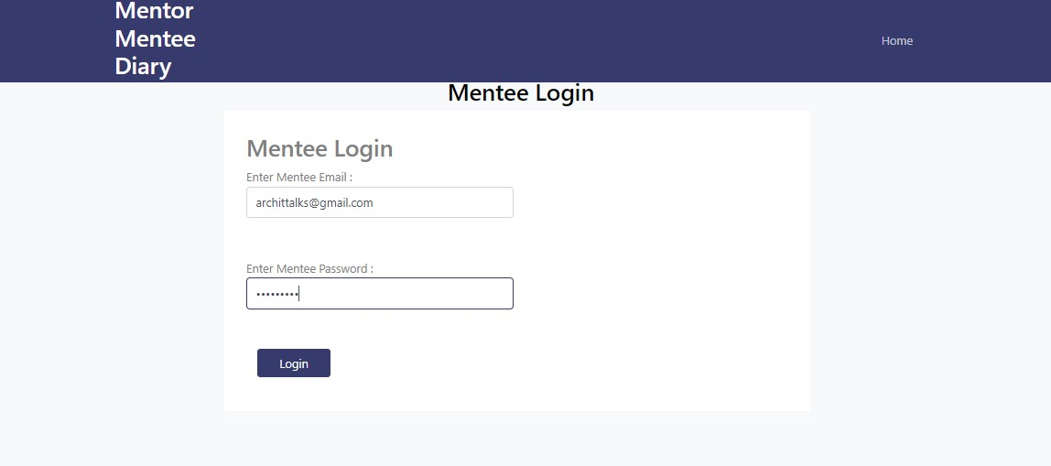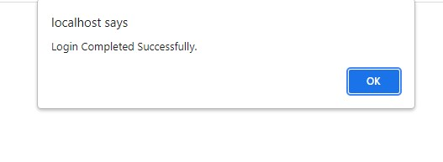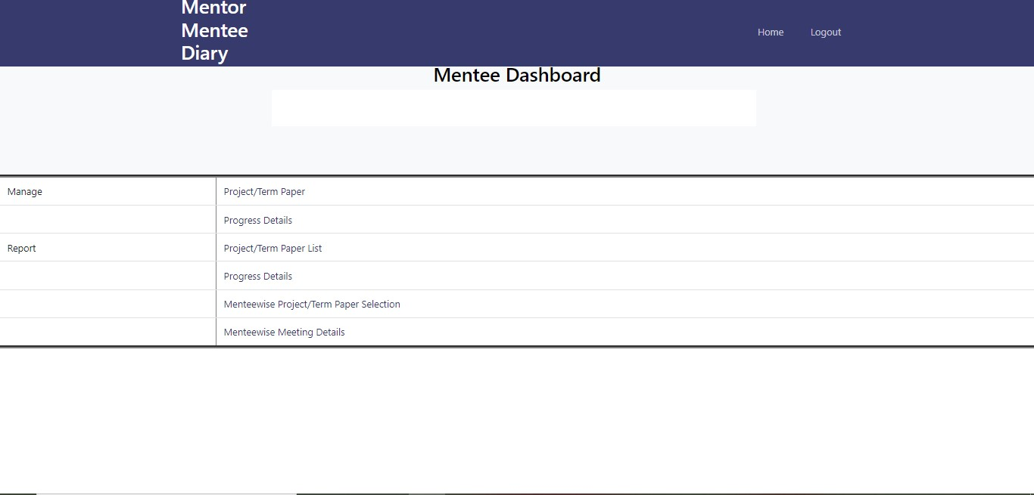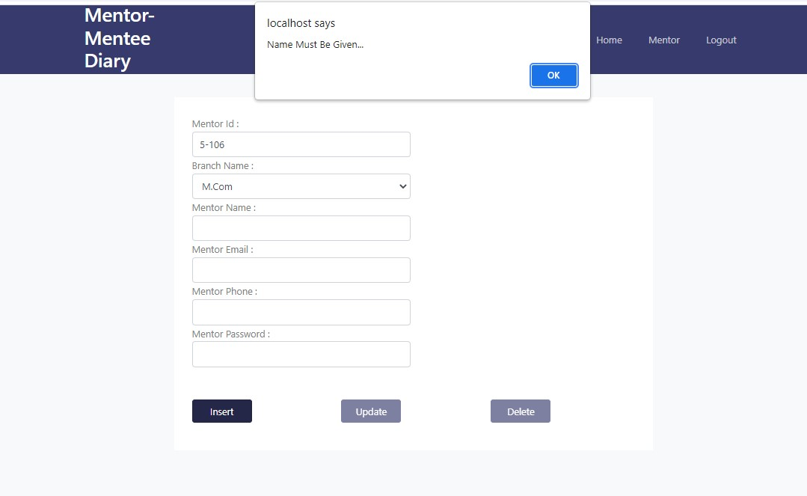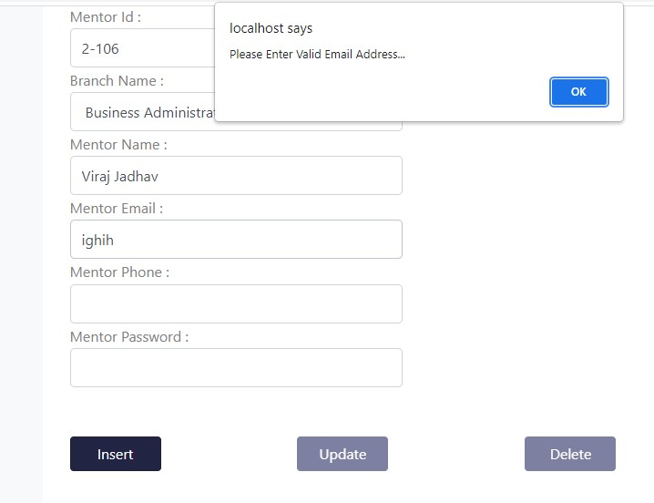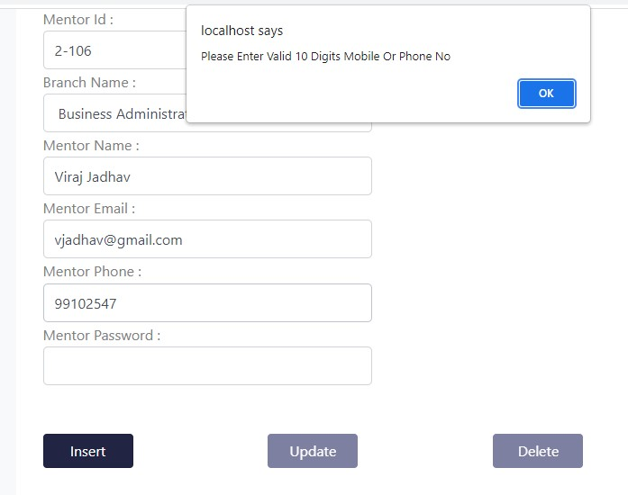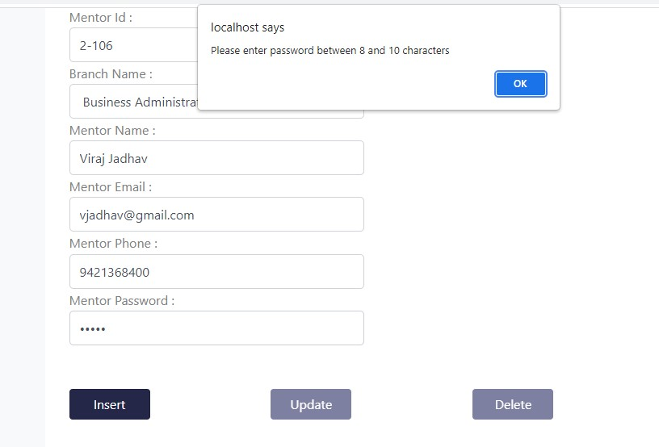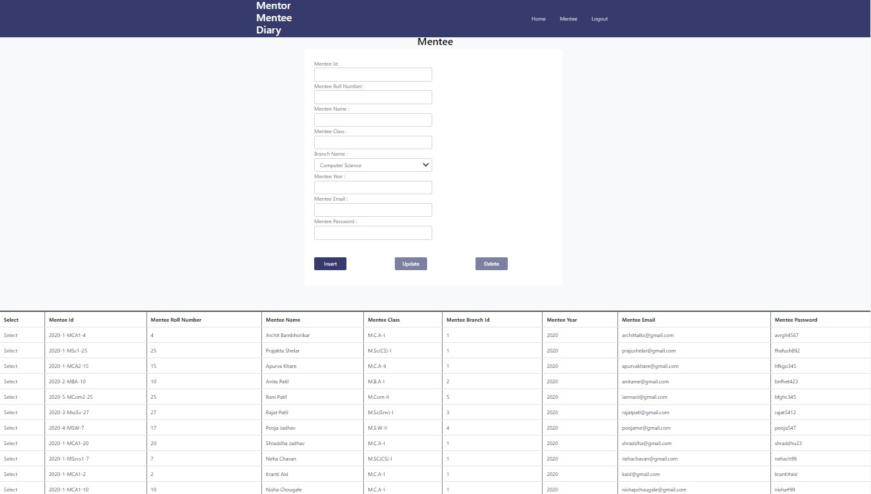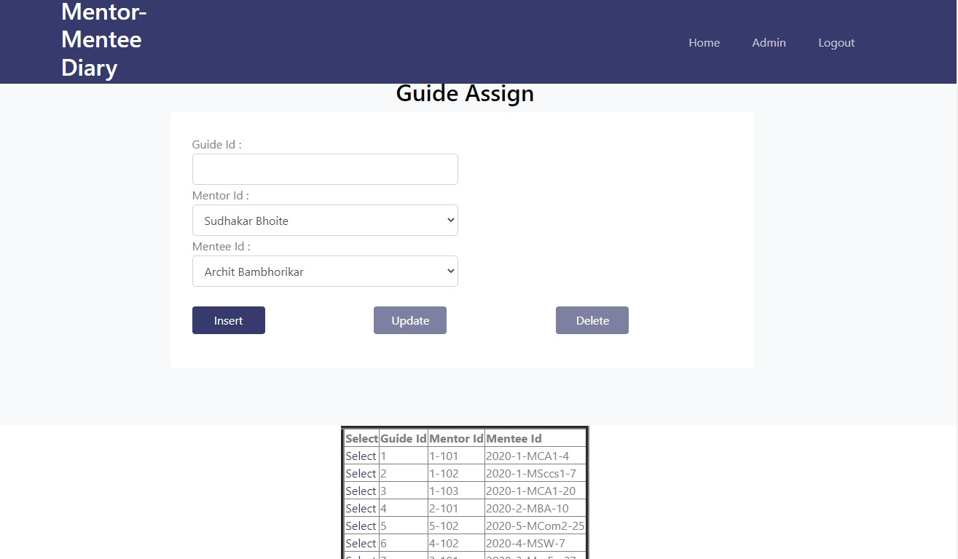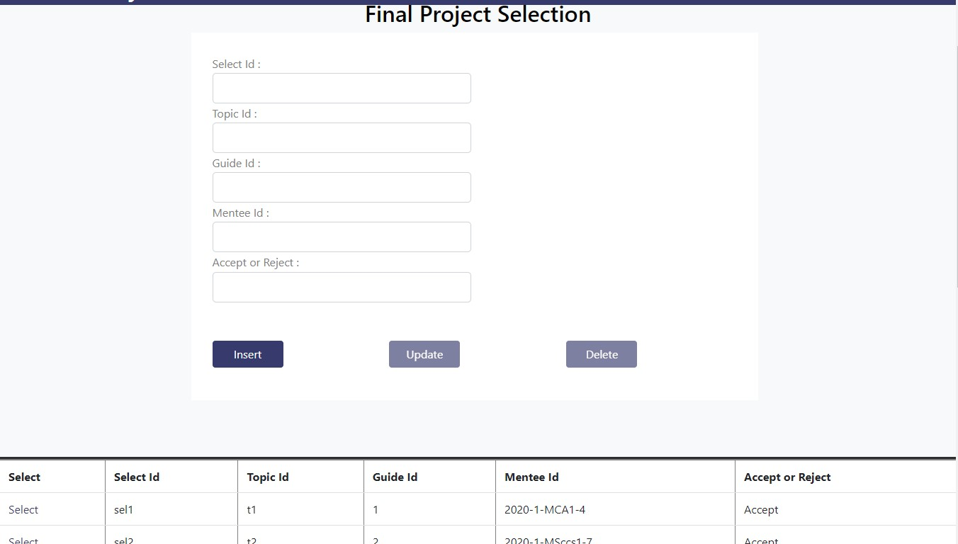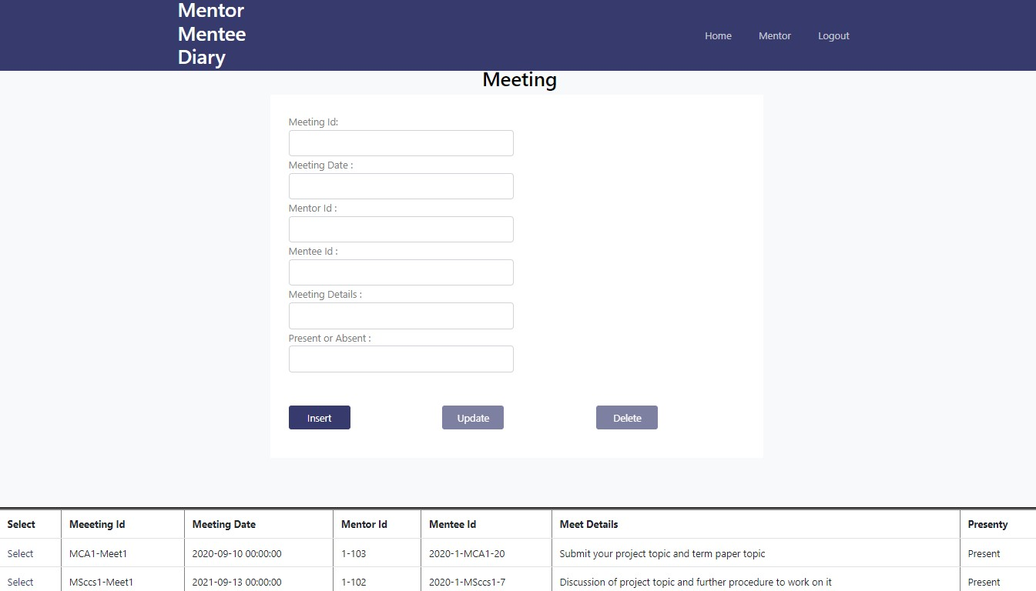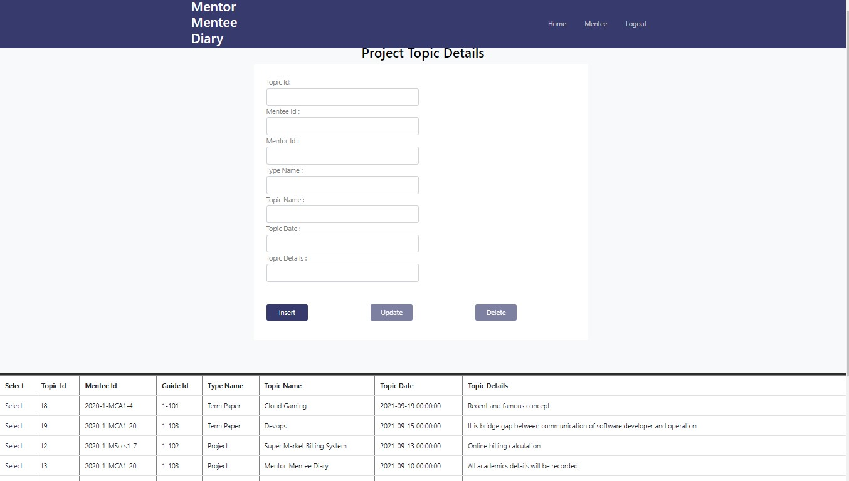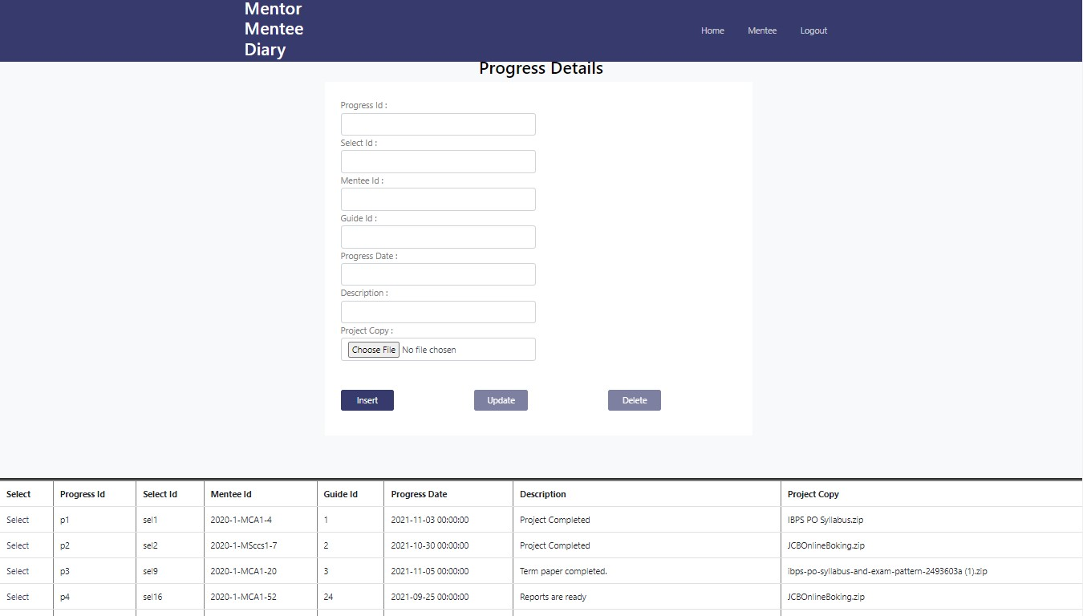

**Reports**

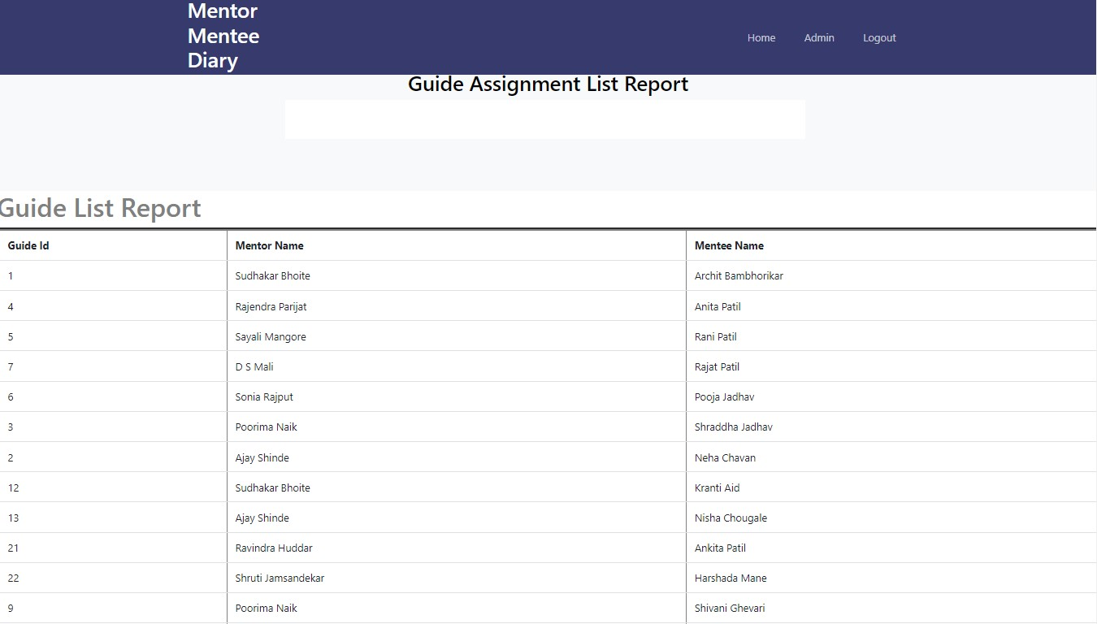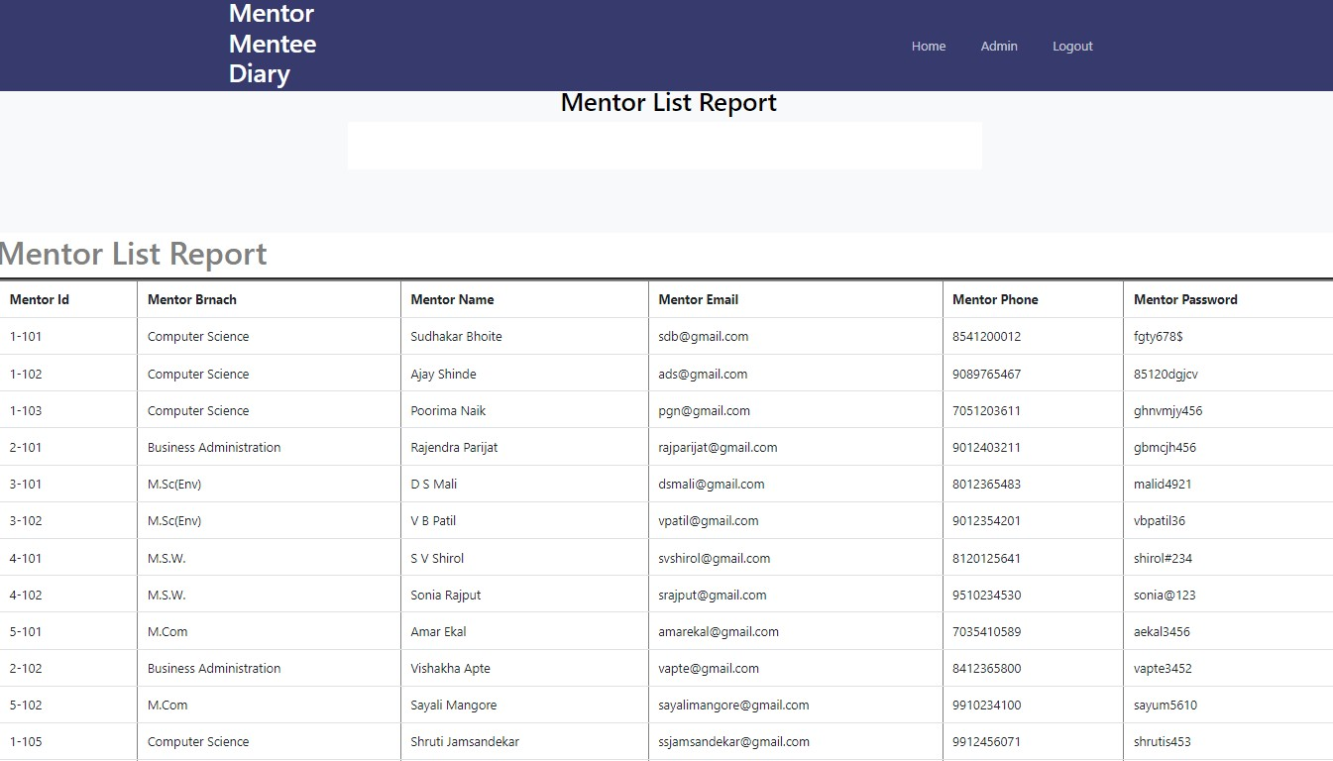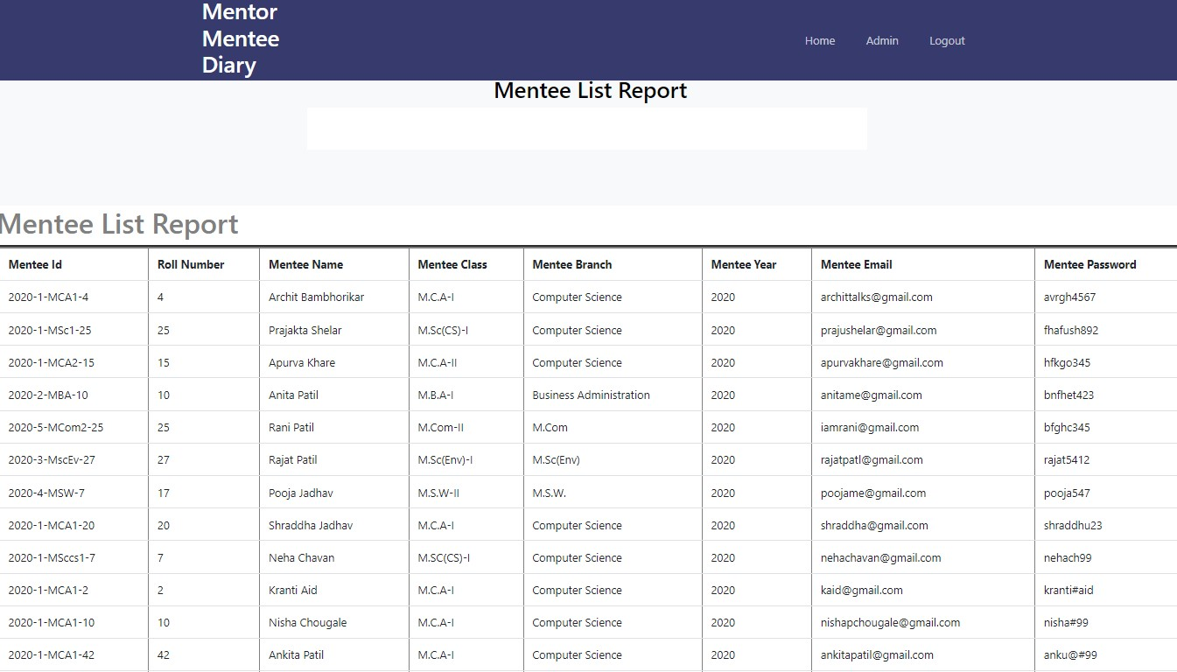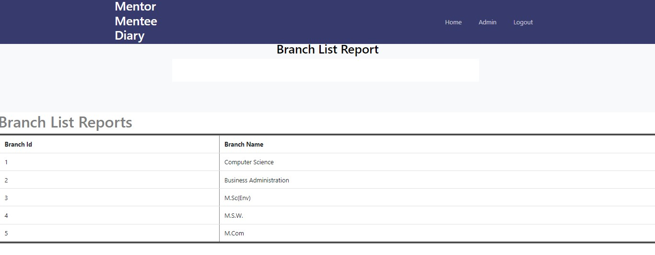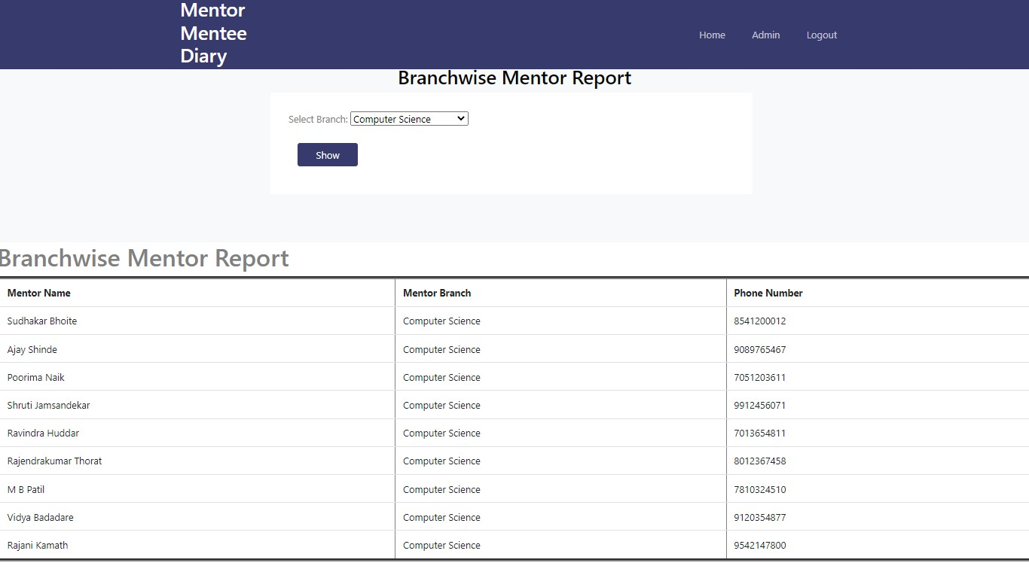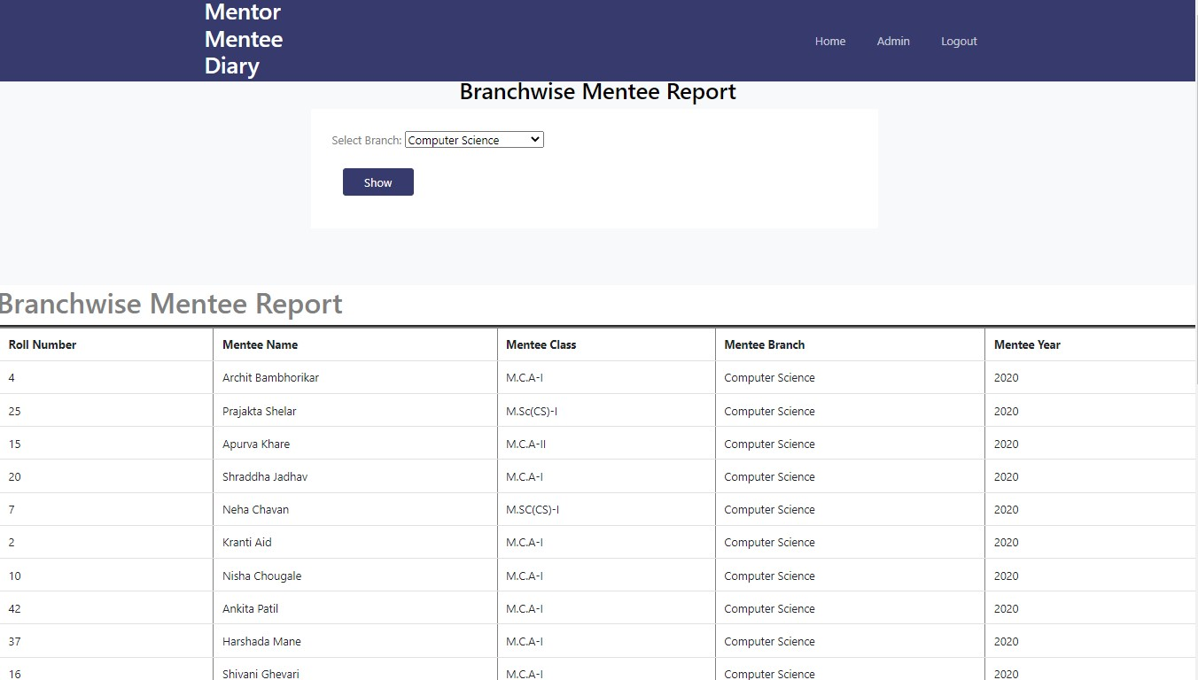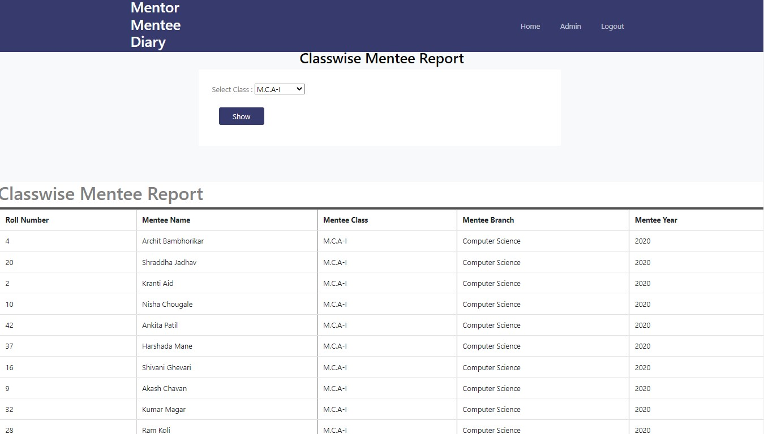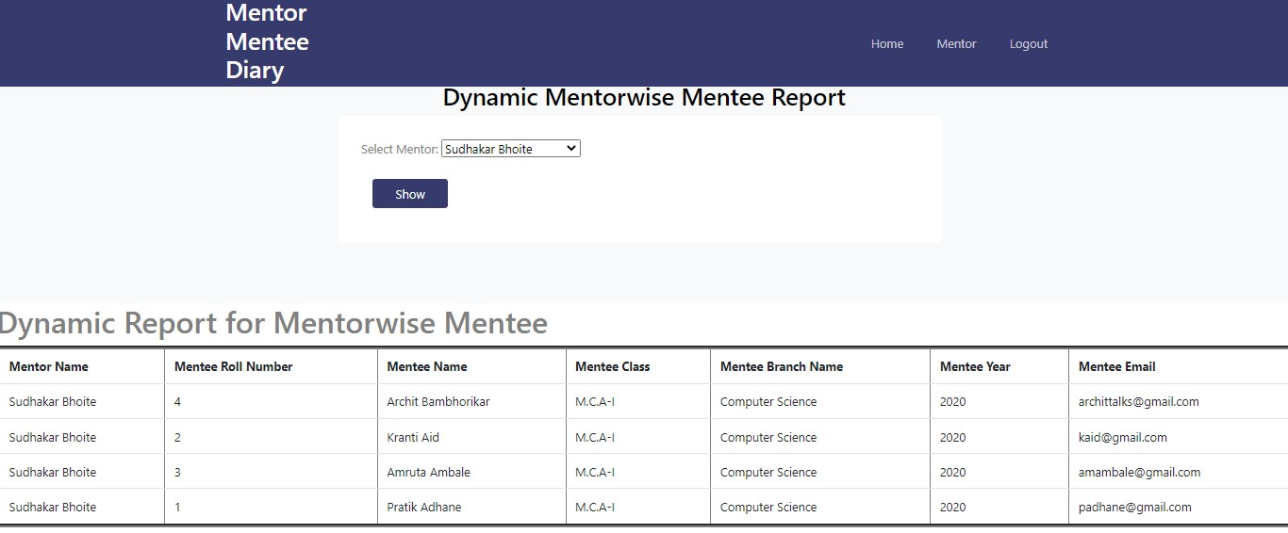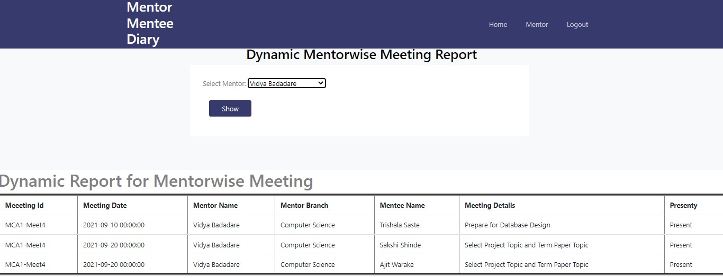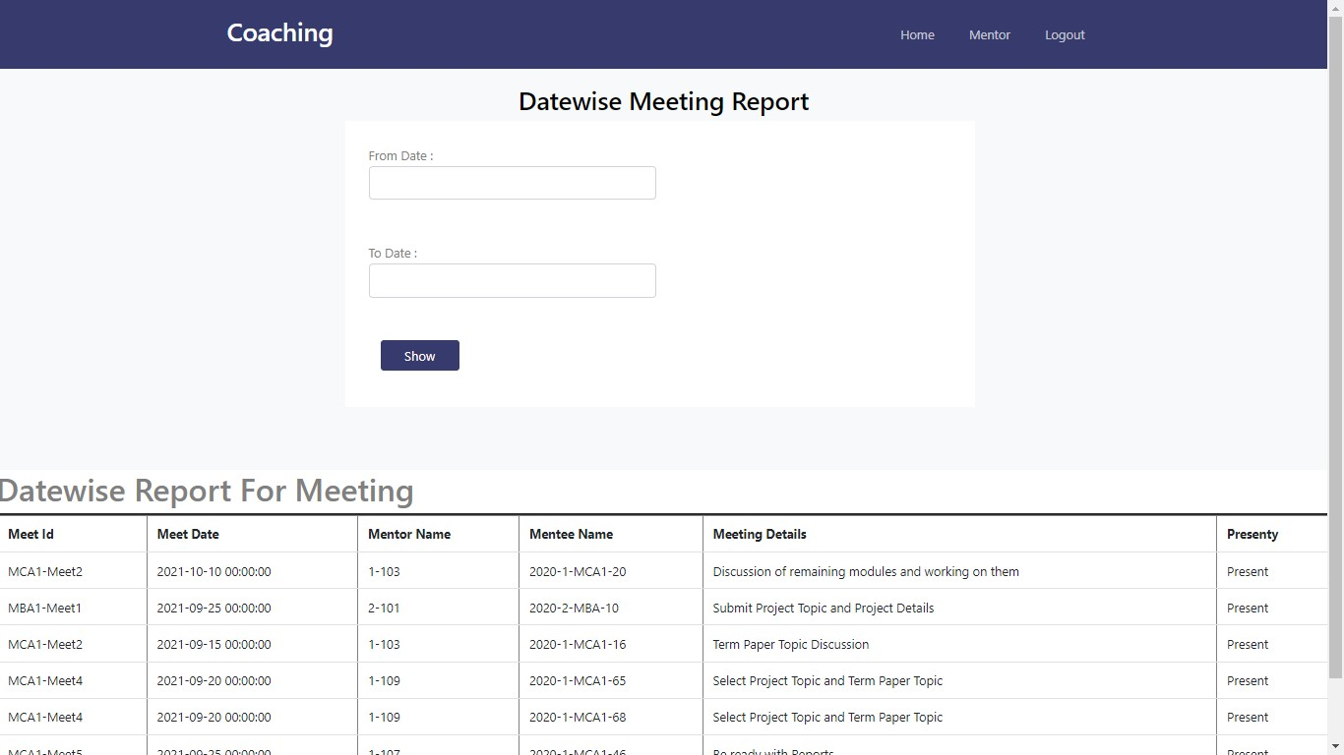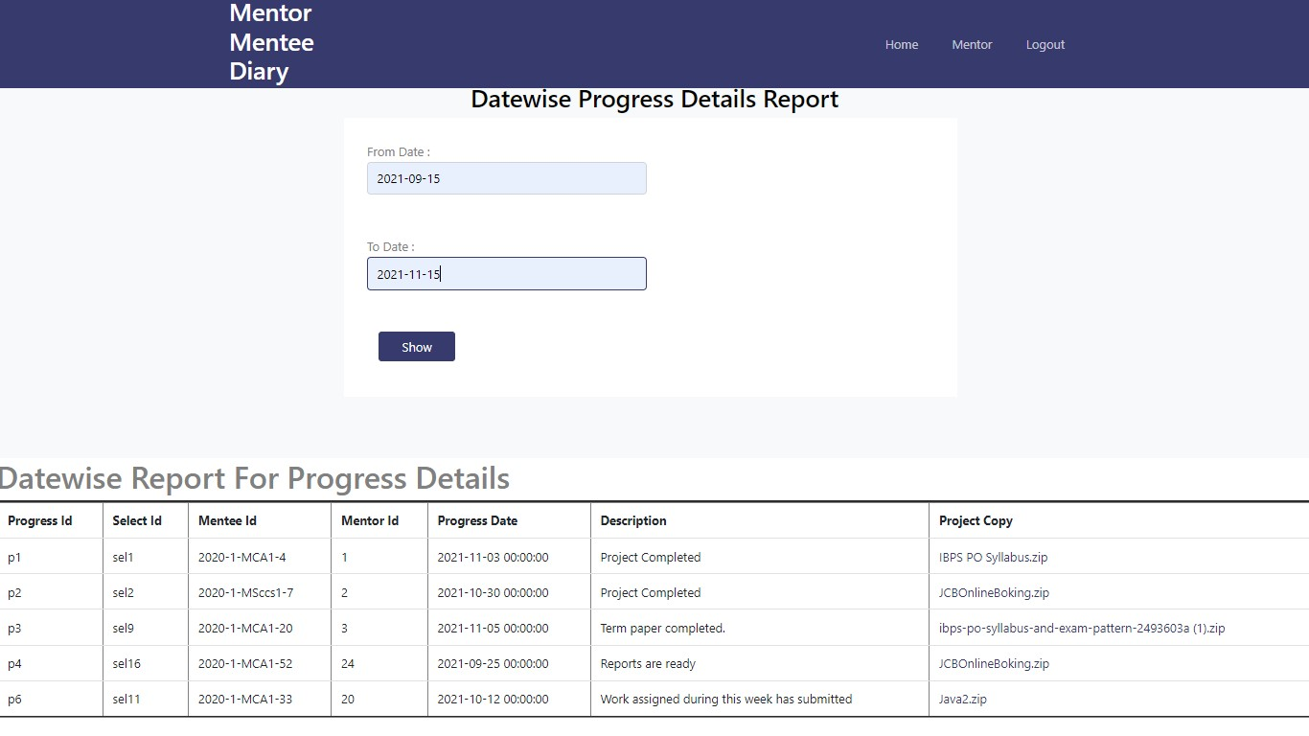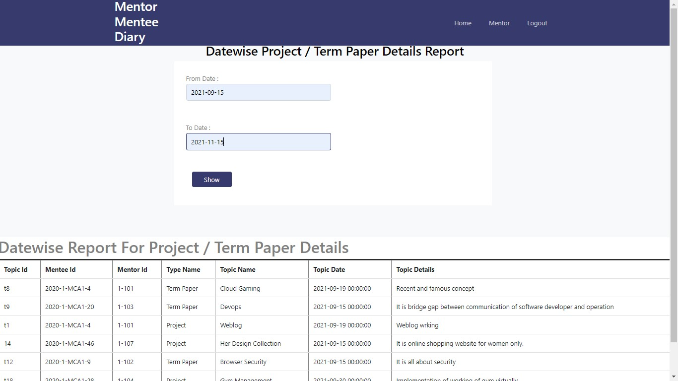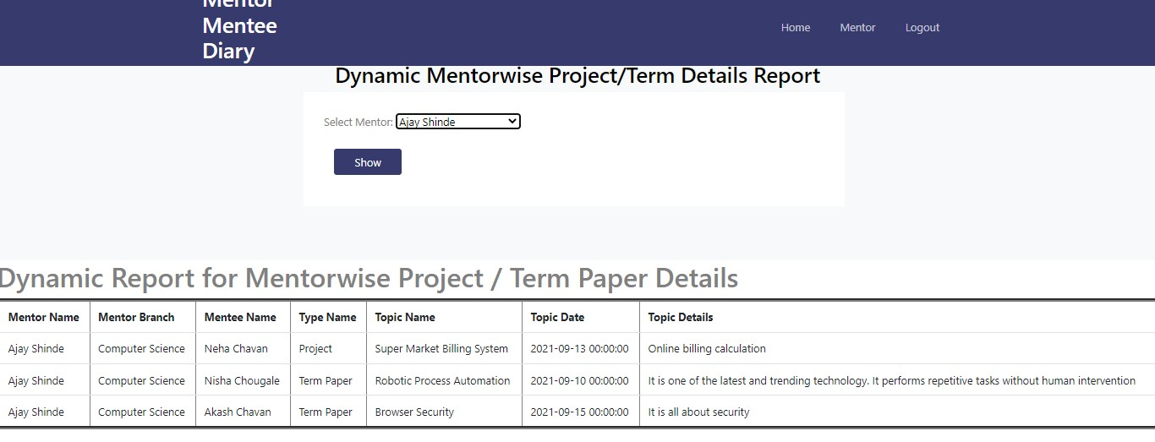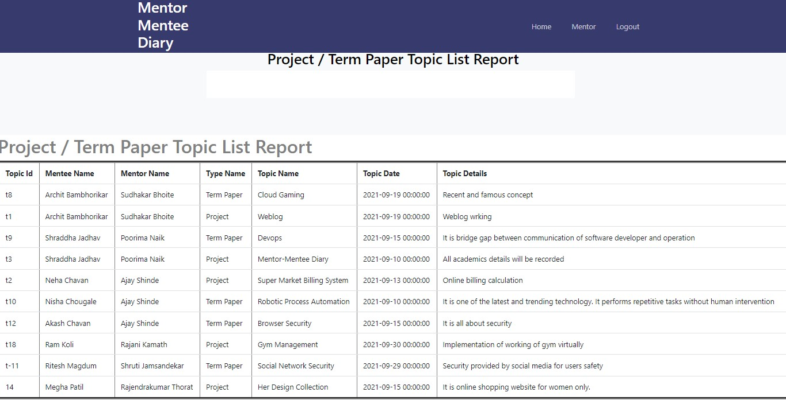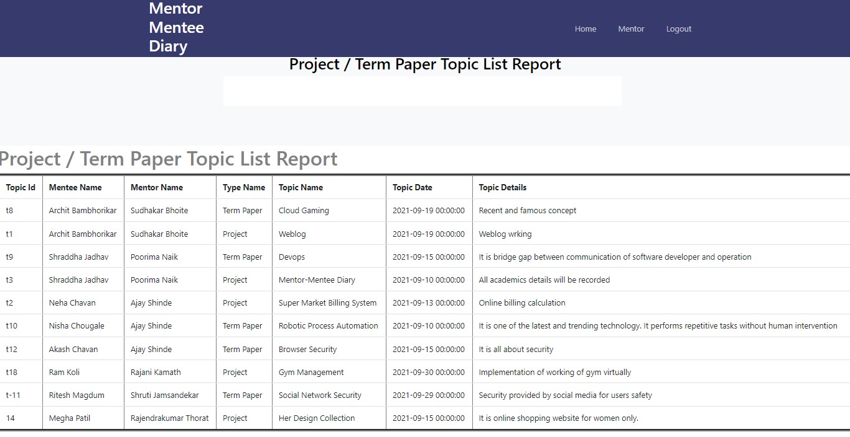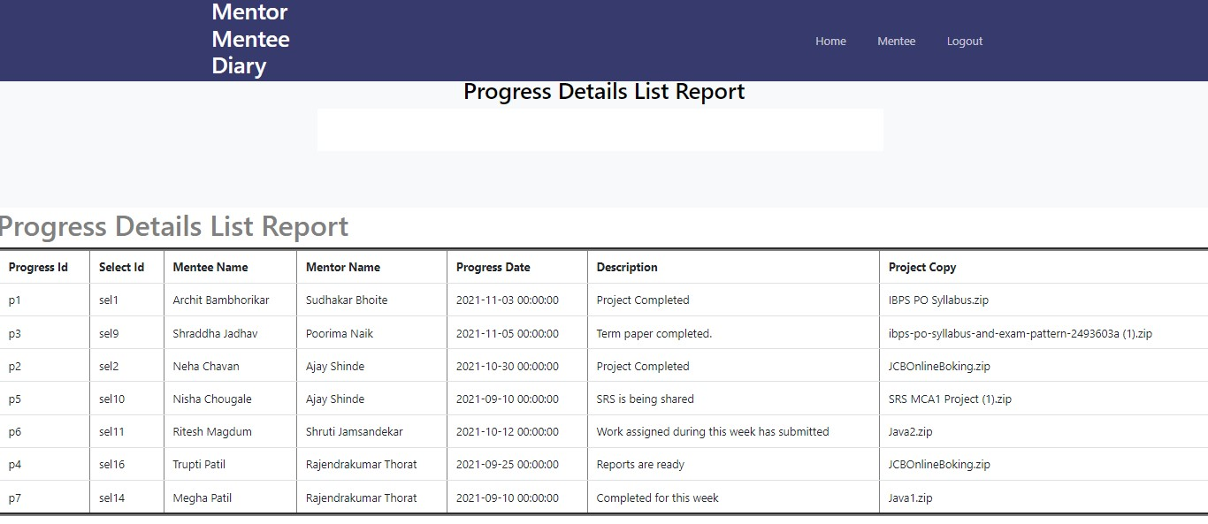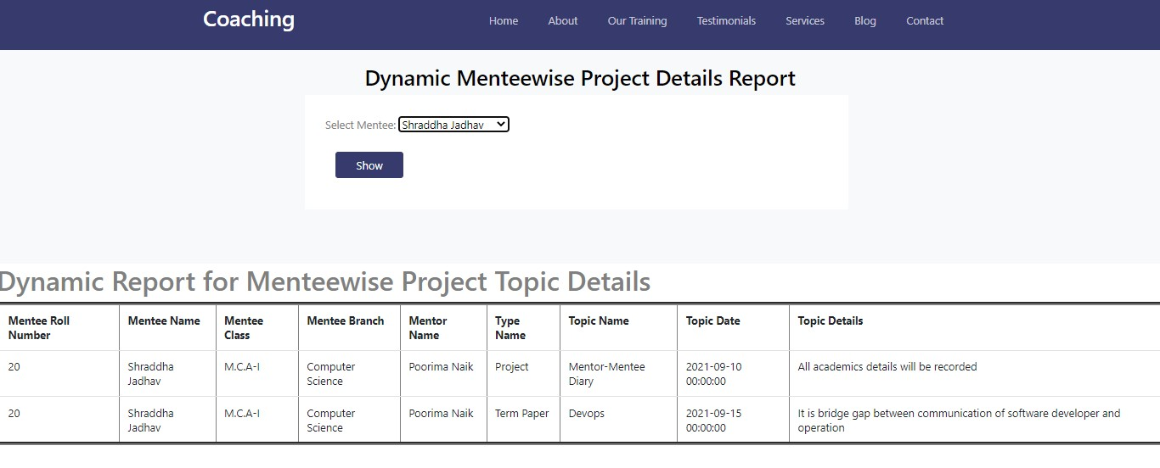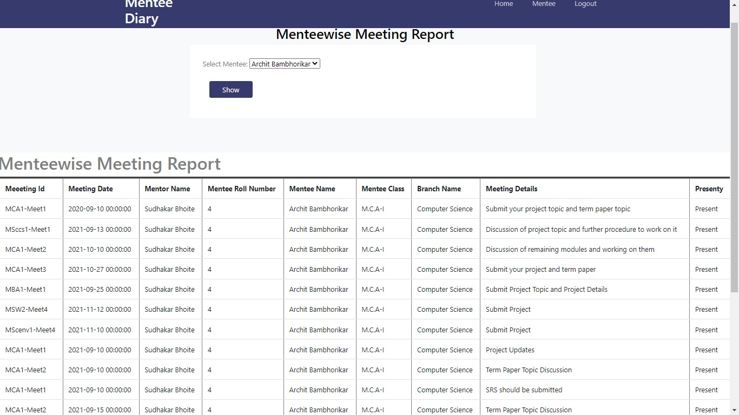

**CONCLUSION**

### Conclusion

* The project has given us good experience . It taught us that the implementation of concepts in HTML, CSS and PHP. Hence the more knowledge about these languages has acquired in very well manner.
* The system provides the facility to perform academic activities in online manner. So academic activities do not get paused or stopped, the system resumes these activities.
* There is time flexibility so mentors and mentees can manage their working according to their time.
* The system is user friendly and easy to use for users.

**LIMITATIONS**

### Limitations

* Implementation of only one activity has been developed in system that is for submission of project or term paler or seminar .
* Also mentors have to record attendance of respective mentees manually during online meeting.

## **FUTURE**

**ENHANCEMENT**

### Future Enhancement

* We will try to implement other activities those take place in academic year.

* As well as we will implement facility for automatic attendance of mentees during online meets.

**BIBLIOGRAPHY**

**Bibliography**

* + [https://www.google.com](https://www.google.com/)

* + [https://w3schools.com](https://w3schools.com/)

* + [https://www.getbootstrap.com](https://www.getbootstrap.com/)

* + [https://www.stackoverflow.com](https://www.stackoverflow.com/)